## Talaria TWO SDK Package

Download the latest SDK package from the InnoPhase IoT website by following the subsequent steps:

1. Go to the InnoPhase IoT website (<https://innophaseiot.com/>) and click on Register.

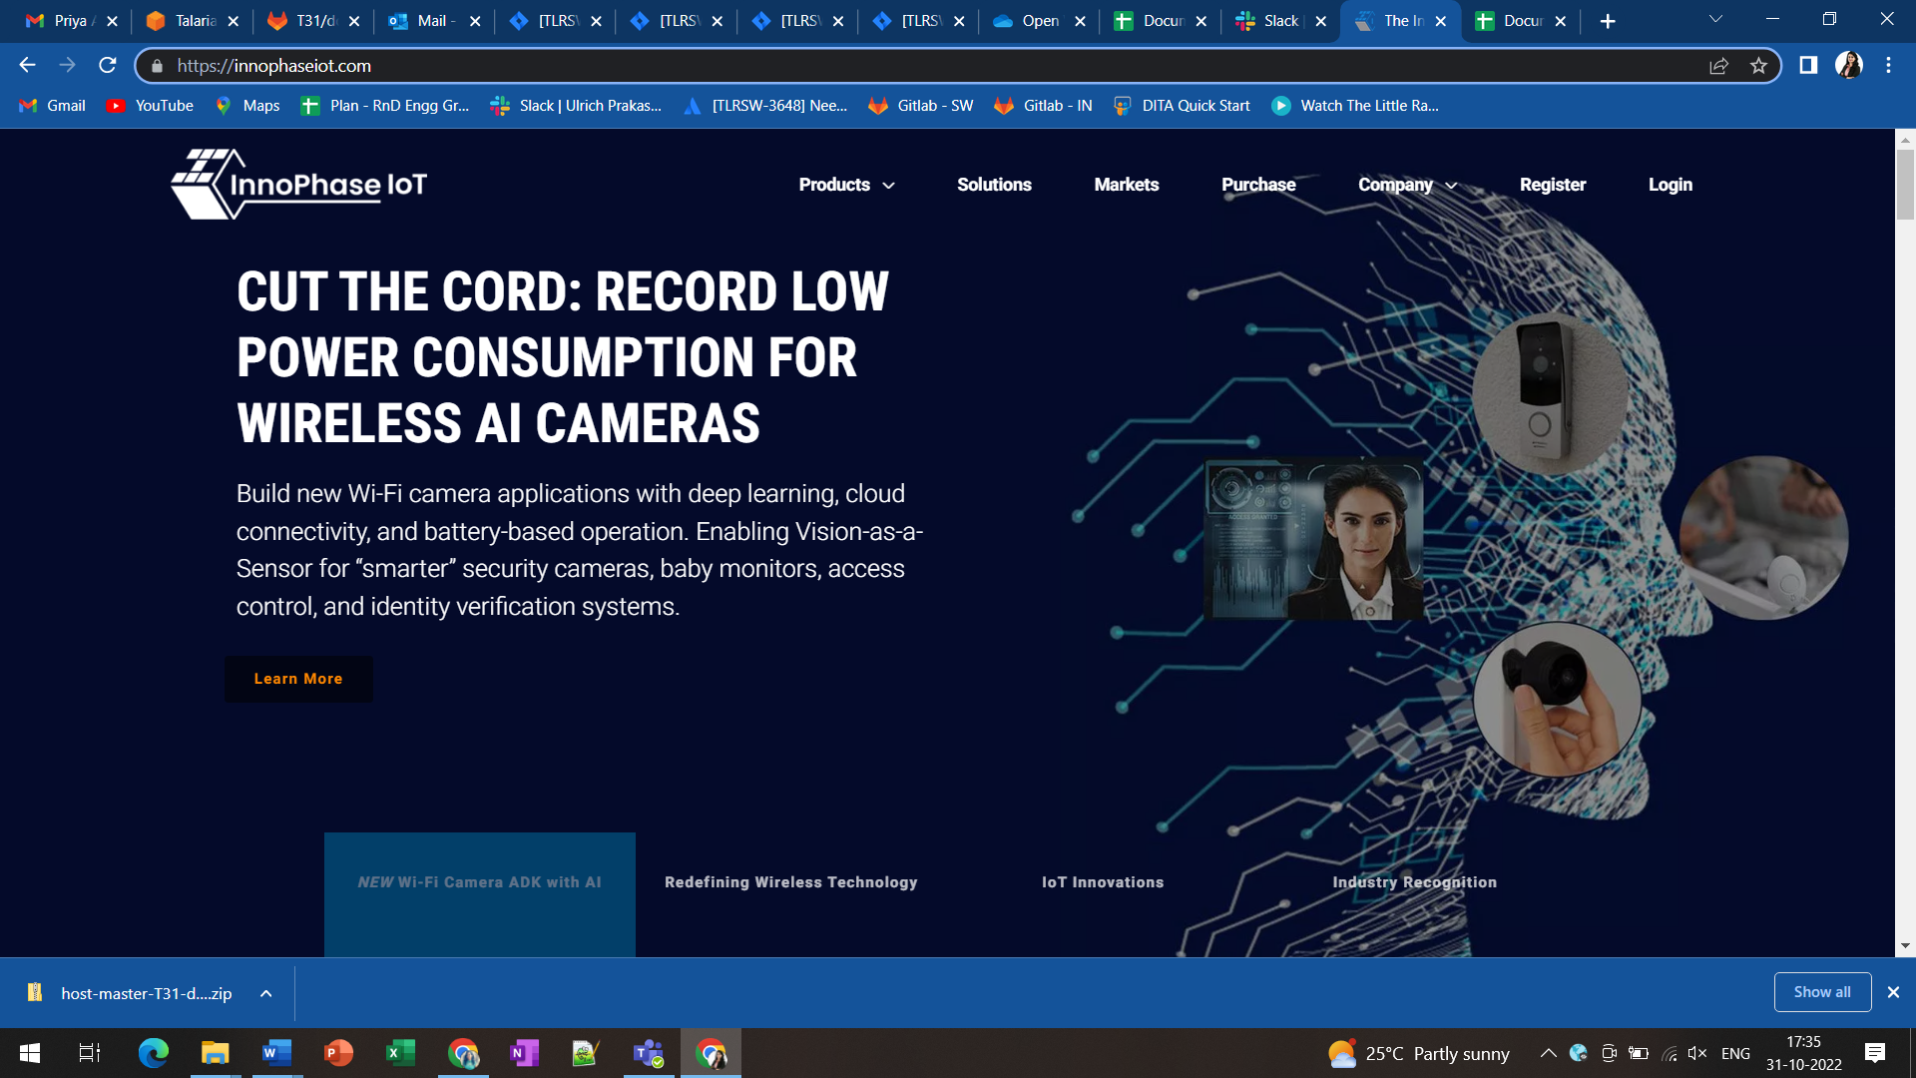

Figure 1: InnoPhase IoT website

1. Provide the appropriate details to register onto the InnoPhase IoT Customer Portal.

**Note**: InnoPhase IoT requires a signed MNDA and Development Tool License Agreement (DTLA) to be signed prior to granting access to the Customer Portal.

1. On successfully registering to the Customer Portal, the following screen will appear:

Figure 2: Customer portal registration

1. Navigate to the Software Tab and download the appropriate software package(s):

Figure 3: Software tab

**Package Contents:**

The package includes dual_stack folder (Path: *sdk_x.y\solutions\dual_stack*).

**Note**: x and y in sdk_x.y refers to the SDK release version.

The dual_stack folder contains the following:

1. docs:

Readme which includes details of Files and folders of Talaria TWO Dual-Stack solution.

1. bin:

Pre-built binaries (dualstack.elf and dualstack_sdio.elf).

1. src:

Source code of Dual-Stack, and custom groups.

1. lib:

Dual-Stack library/source.

1. fs:

Contains json files.

1. firmware_upgrade_images:

Root files.